**Deploy war file into Tomcat from Jenkins**

In this article, we will create 3 Jenkins jobs

Compile -> deploy ->test

1. PetStoreCompile - Compile the source code of the project from GitHub
2. PetStoreTomcatDeploy – Create package a project as .war file and deploy it into Tomcat server.
3. PetStoreMavenSeleniumTest – Test the PetStore application which got deployed in tomcat.
4. PetStoreCompile - Compile the source code of the project from GitHub

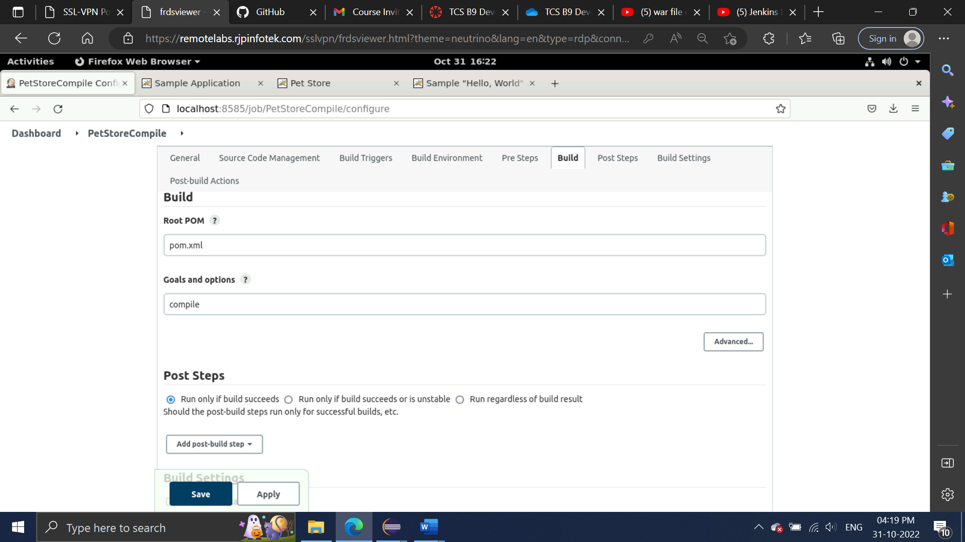

1. PetStoreTomcatDeploy – Create package a project as .war file and deploy it into Tomcat server.

[How To Install Apache Tomcat 10 on Ubuntu 20.04 | DigitalOcean](https://www.digitalocean.com/community/tutorials/how-to-install-apache-tomcat-10-on-ubuntu-20-04)

Downloaded tomcat into local folder and followed the below instructions.

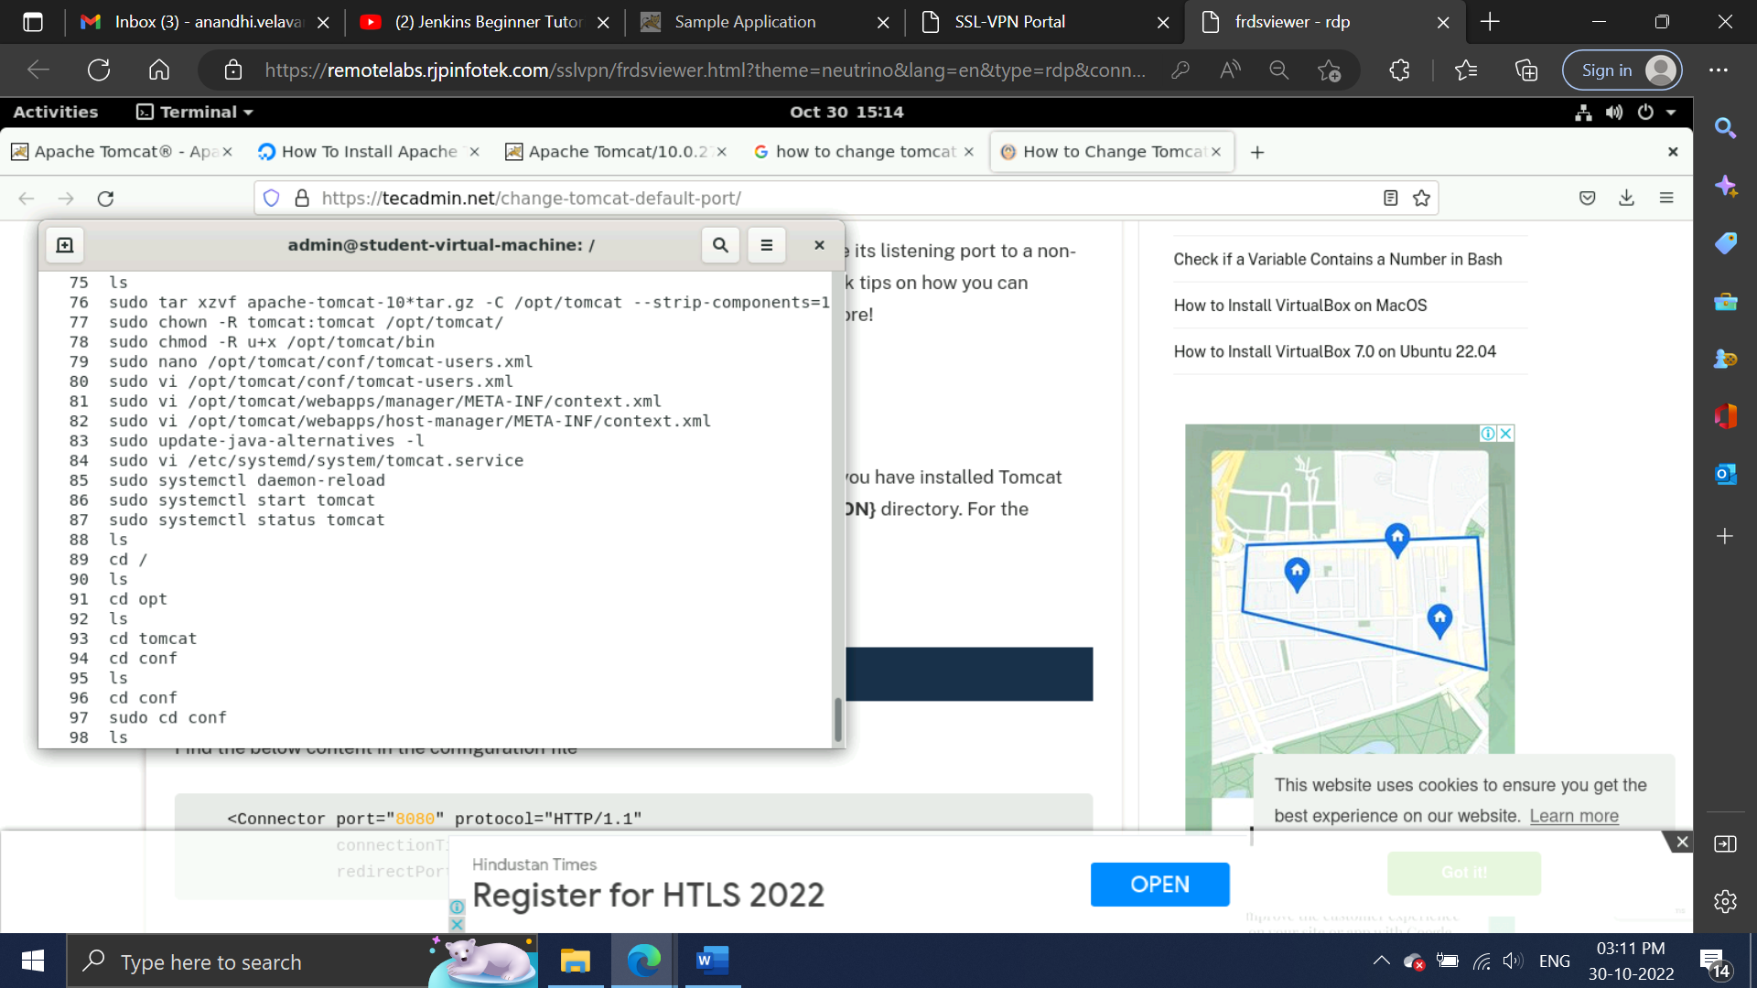

To modify server port

* sudo vi /opt/tomcat/conf/server.xml

Modify Connector port to 9090.

To deploy into tomcat, give permission as manager-script to user,

sudo vi /opt/tomcat/conf/tomcat-users.xml

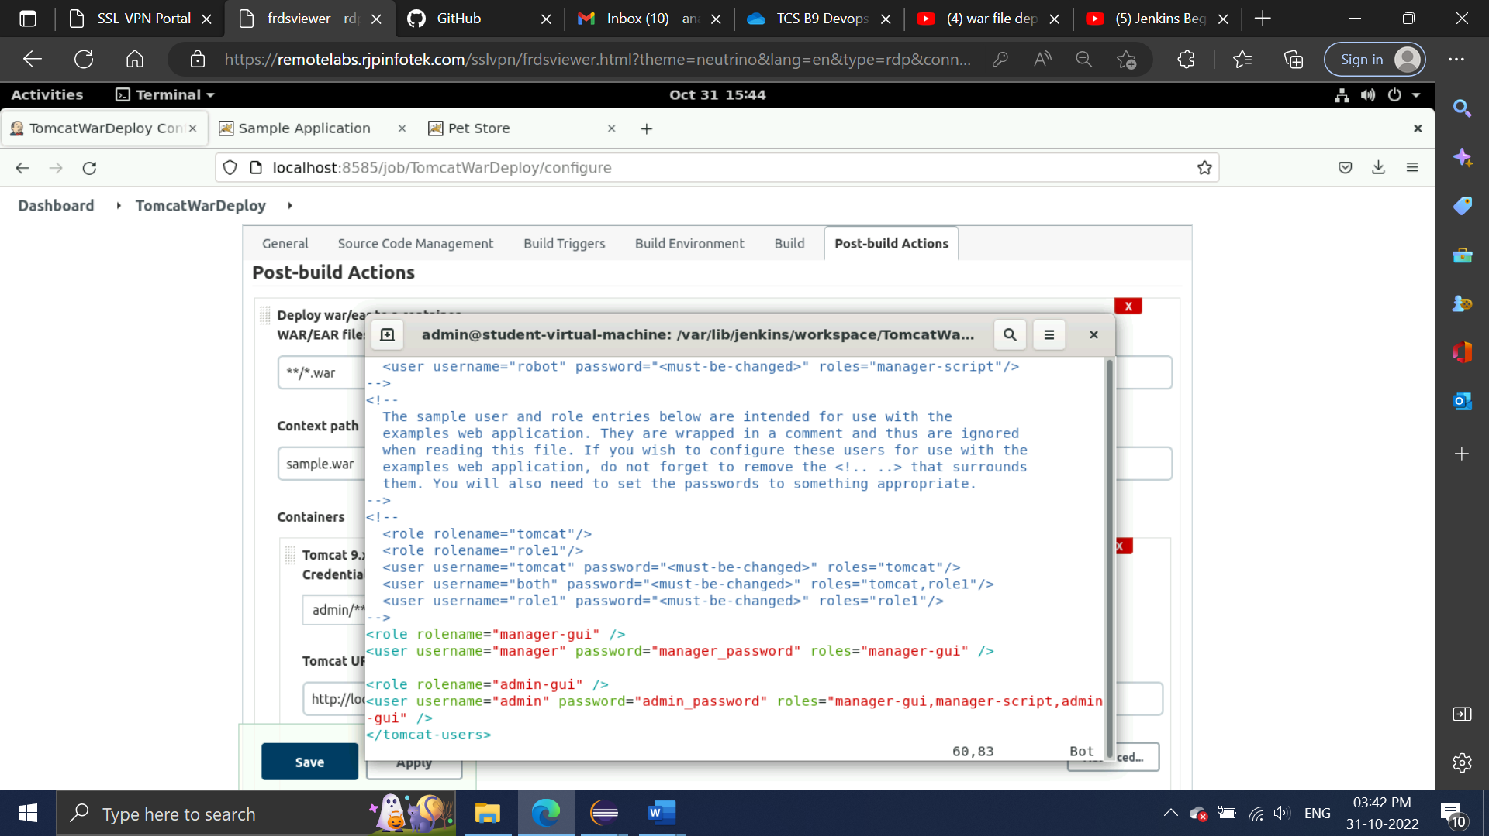

Deploy application to Tomcat from Jenkins,

* 1. Install plugin ‘Deploy to container’
  2. Create a maven project
  3. 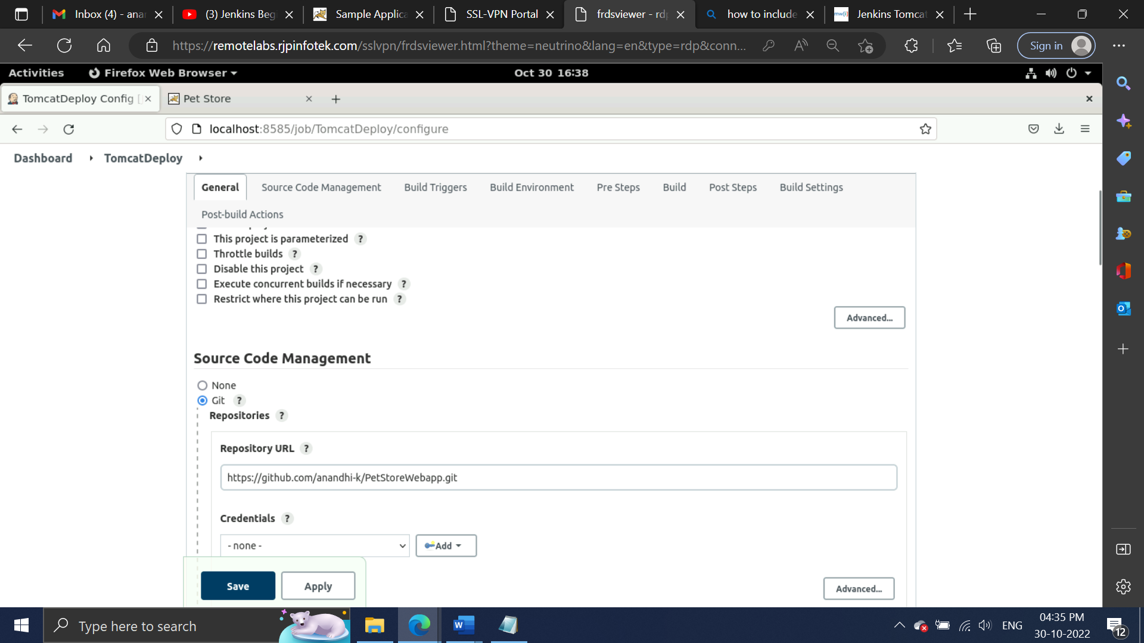
  4. 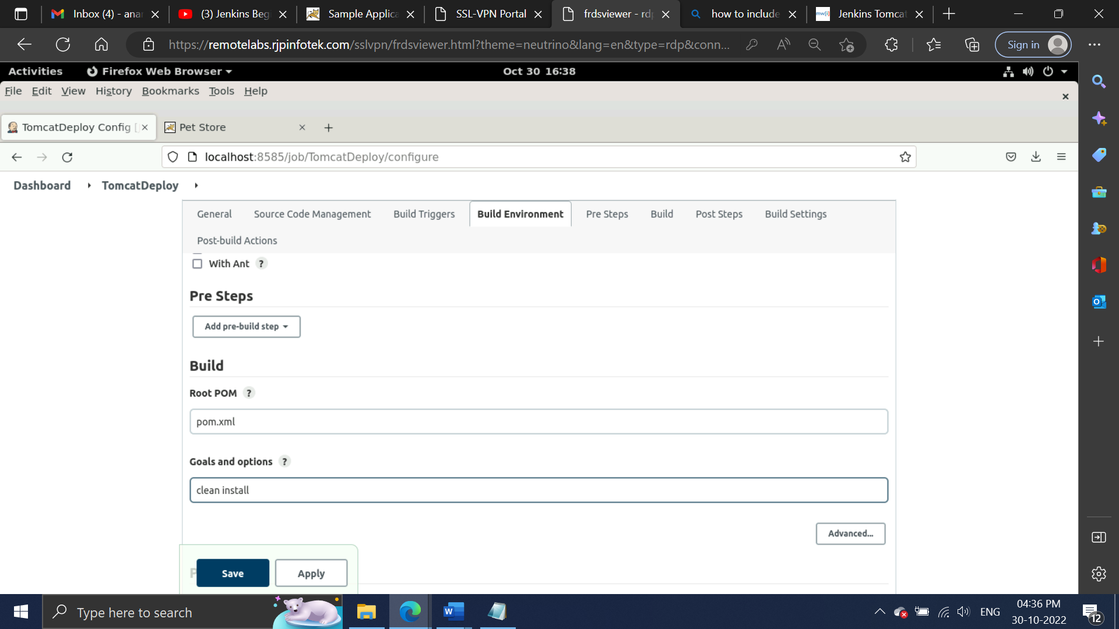
  5. 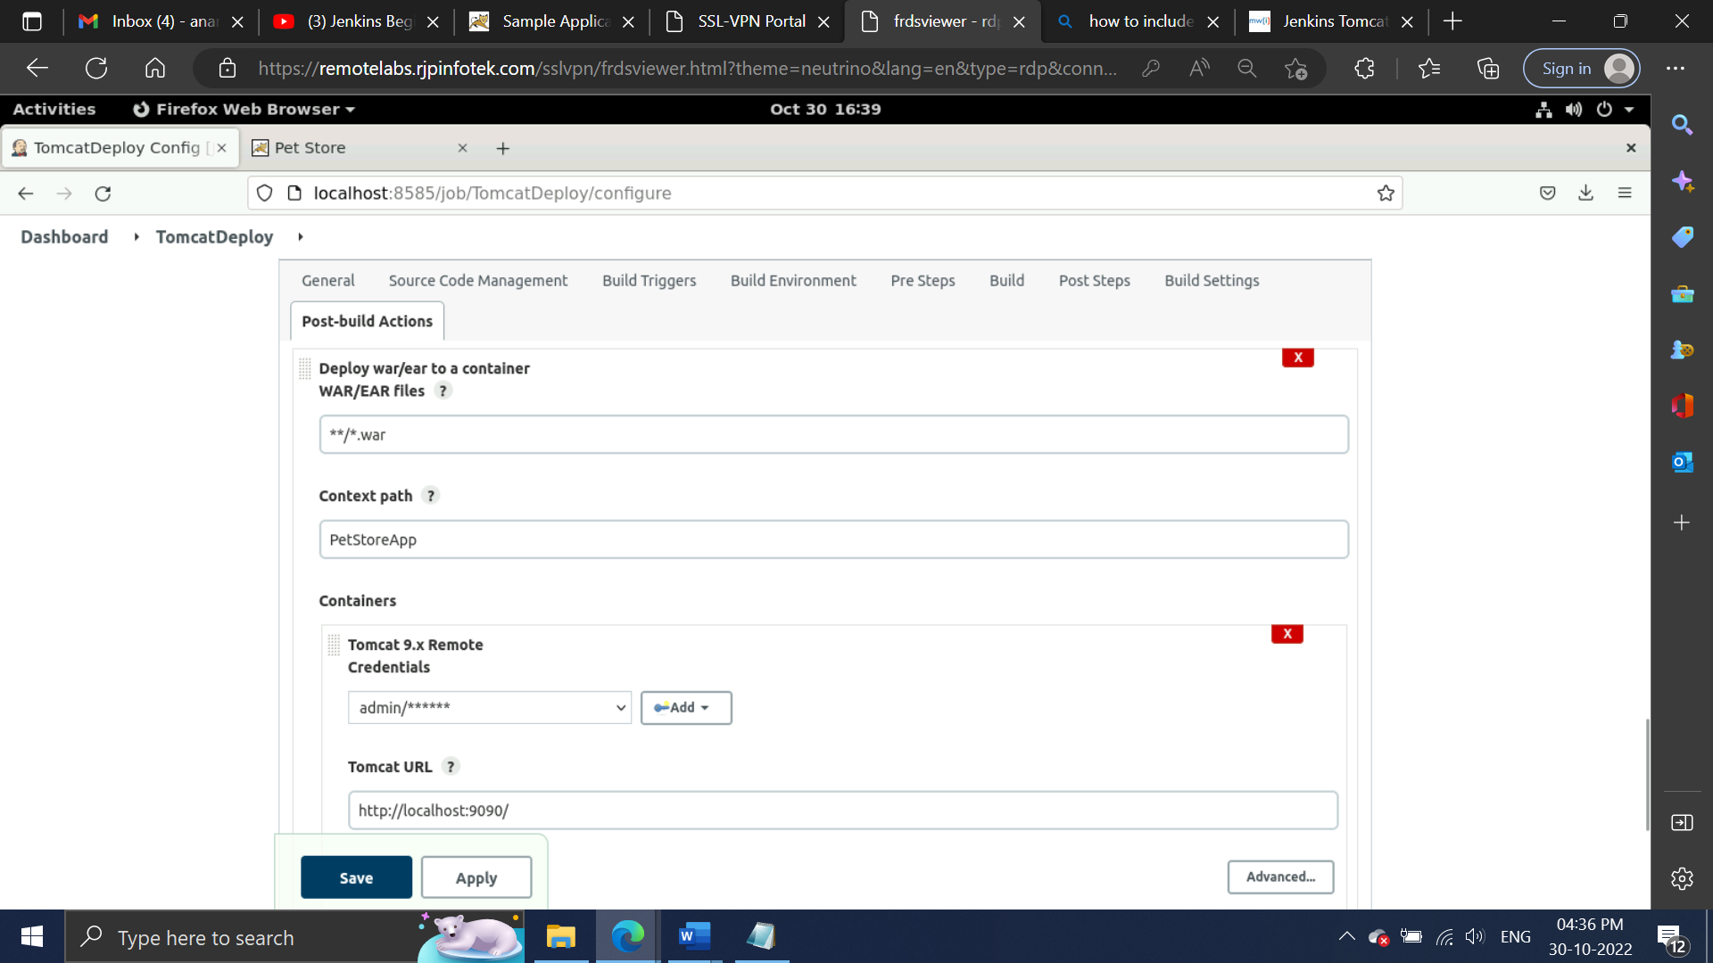
  6. Configure Tomcat user name in Jenkins and select that user here.
  7. Build the application
  8. And Launch it with

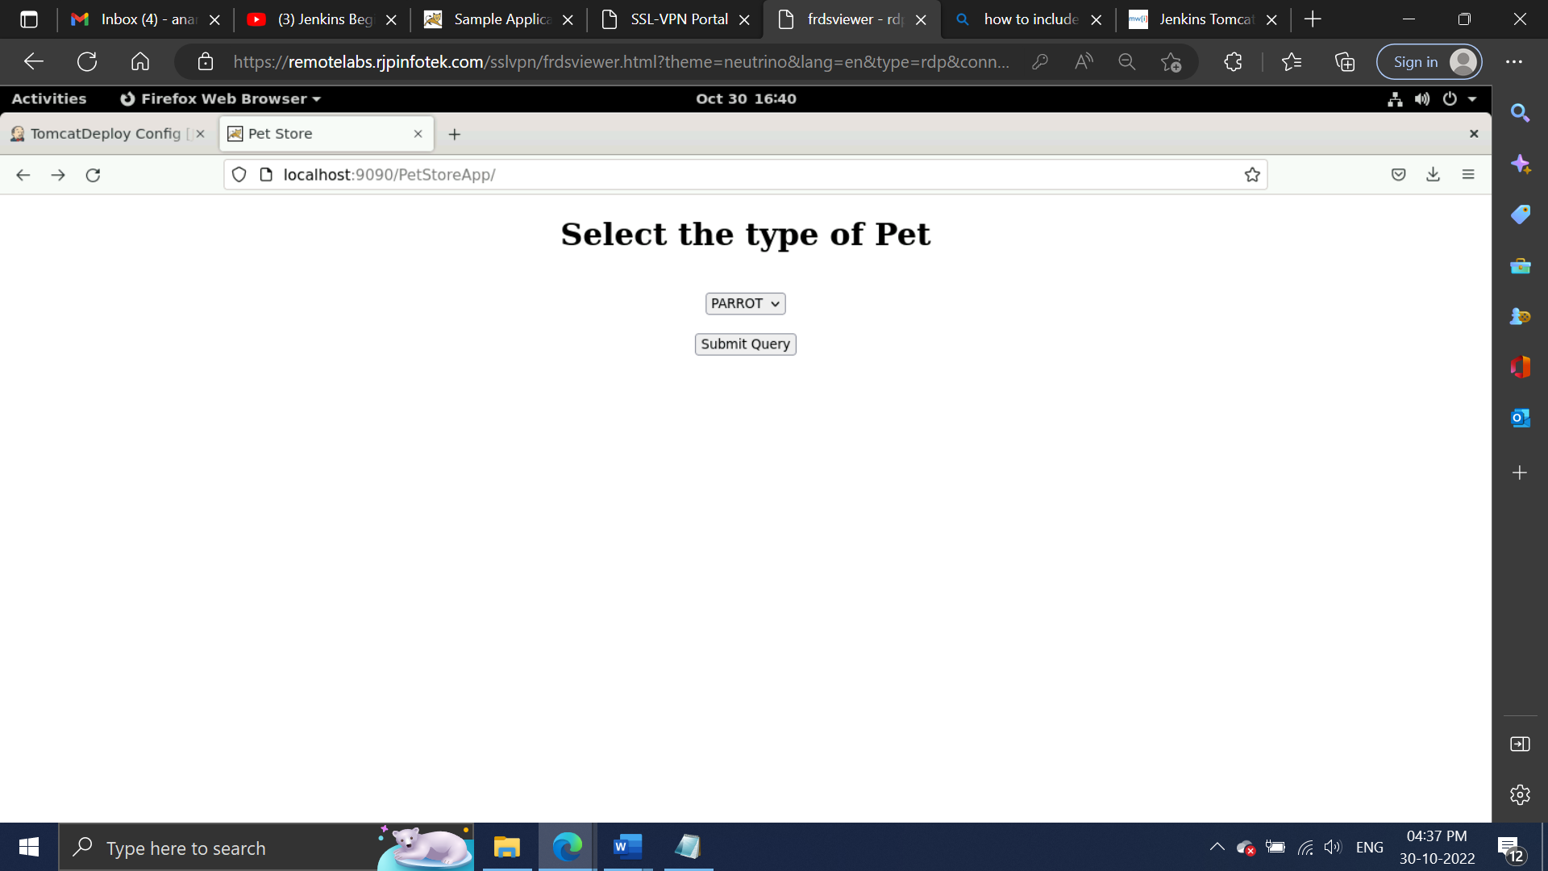

1. PetStoreMavenSeleniumTest – Test the PetStore application which got deployed in tomcat.
2. Create a maven project using

https://github.com/anandhi-k/petstoretest.git

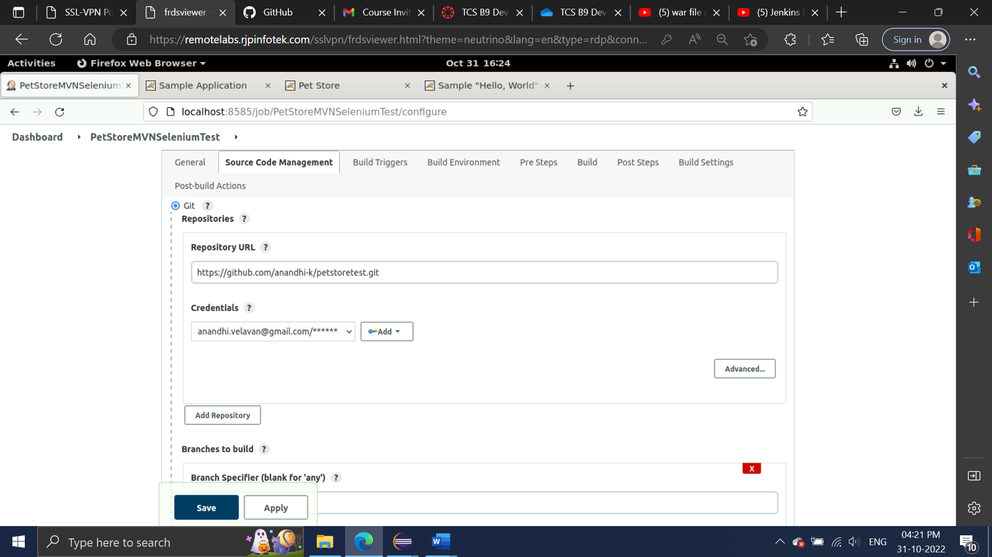

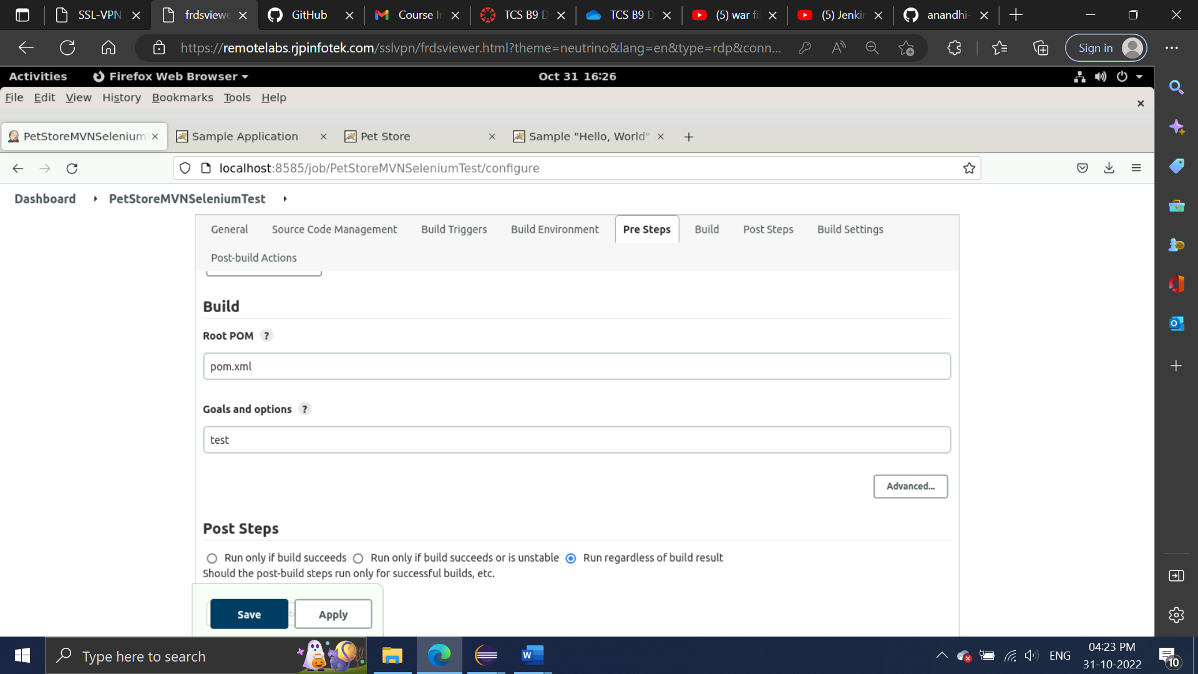

After build, view the console output as,

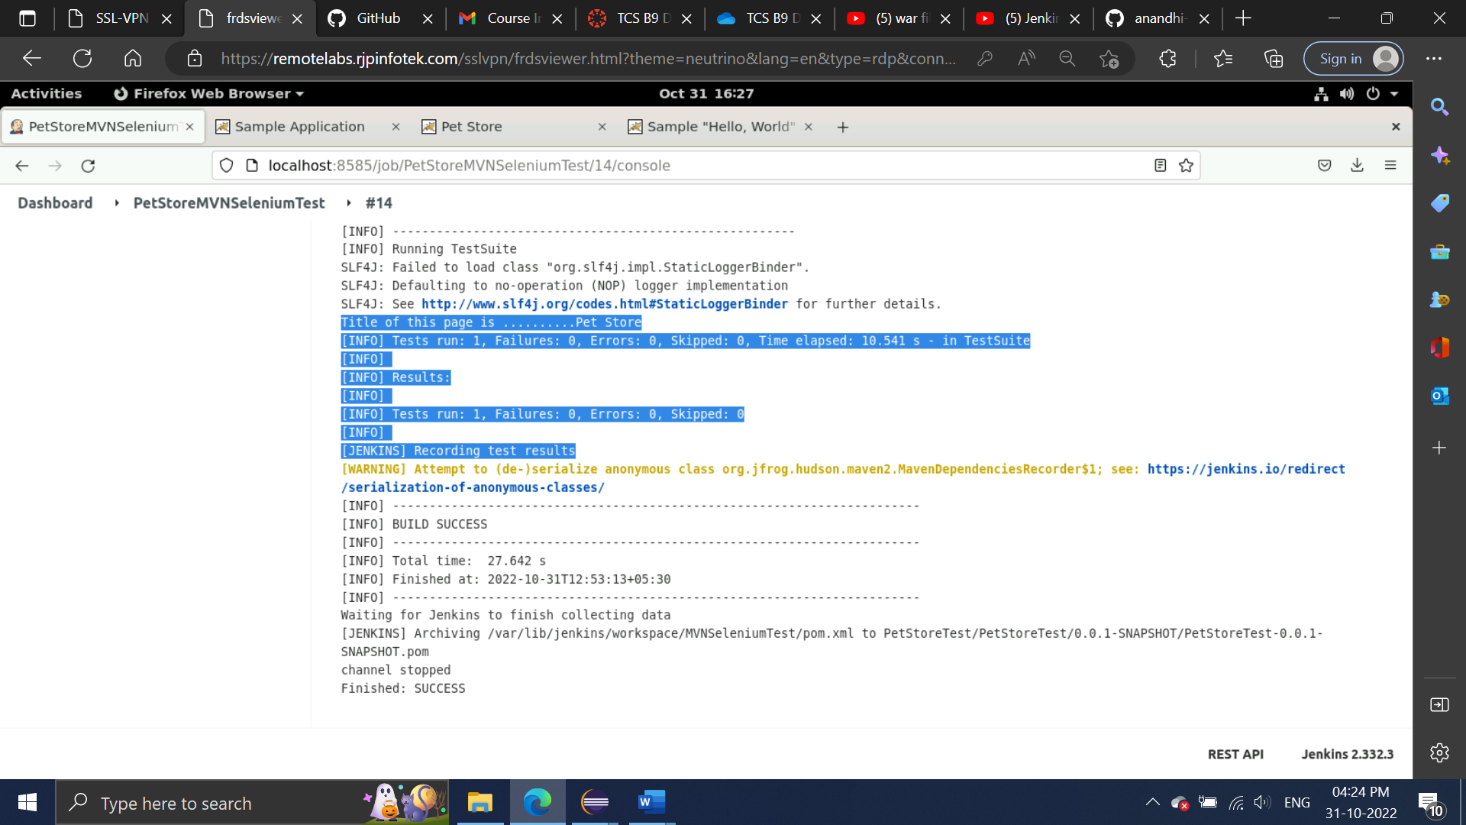

Scripted Pipeline :

